Data Science Toolbox: Python Programming
PROJECT REPORT
(Project Semester January-April 2025)

Credit Card Data Analysis

Submitted by

Kush Gulati

Registration No 12325077

Computer Science and Engineering(K23SM)
Course Code INT375

Under the Guidance of

Dr. Mrinalini Rana(UID: 22138)

Discipline of CSE/IT

Lovely School of Computer Science and Engineering

Lovely Professional University, Phagwara

CERTIFICATE

This is to certify that Kush Gulati bearing Registration no. 12325077 has completed INT375 project titled, “Credit Card Data Analysis” under my guidance and supervision. To the best of my knowledge, the present work is the result of his/her original development, effort and study.

Signature and Name of the Supervisor
Designation of the Supervisor
School of Computer Science and Engineering
Lovely Professional University
Phagwara, Punjab.

Date:

DECLARATION

I, Kush Gulati student of Bachelor in Technology under CSE/IT Discipline at, Lovely Professional University, Punjab, hereby declare that all the information furnished in this project report is based on my own intensive work and is genuine.

Date: 12/04/2025 Signature
Registration No. 12325077 Kush Gulati

Table of Content

1. Introduction
2. Source of dataset
3. Dataset Preprocessing
4. Analysis on dataset (for each objective)
- General Description
- Specific Requirements
- Analysis results
- Visualization
5. Conclusion
6. Future scope
7. References

Introduction
This project involves a comprehensive exploratory data analysis of a German credit dataset. The analysis examines the relationships between various demographic factors and credit behaviors to understand patterns in lending.
The code performs several key analytical tasks:
- Data Loading and Preparation: Imports the German credit dataset and handles missing values in account-related fields
- Demographic Analysis: Investigates how factors like age, sex, job category, and housing type relate to credit amounts
- Financial Behavior Analysis: Examines relationships between credit amount, duration, and account types (saving and checking)
- Purpose-based Analysis: Analyzes how the stated purpose of credit relates to the amount borrowed
- Risk Assessment: Creates risk indicators based on various factors like high credit amounts combined with long durations
The analysis uses visualization techniques including histograms, scatter plots, box plots, correlation matrices, and heat maps to identify patterns in the data. Statistical aggregations help quantify relationships between variables, such as the correlation between credit duration and amount or differences in average credit amounts across demographic groups.
This project would be valuable for financial institutions looking to understand credit patterns, refine lending criteria, or develop predictive models for credit risk assessment.

Source of dataset
https://archive.ics.uci.edu/ml/datasets/statlog+(german+credit+data)

Github Repository Link
https://github.com/kushgulati033/Credit-card-data-analysis.git
Dataset Preprocessing
Data Preprocessing in the German Credit Data Project
The data preprocessing steps in this project are relatively straightforward but essential for the subsequent analysis:
- Initial data exploration: The code starts by examining the dataset structure using df.head(), df.describe(), and df.info() to understand the data types and basic statistics.
- Missing value detection: The code checks for missing values in all columns using df.isnull().sum() and prints the results to identify problematic columns.
- Missing value handling: Two columns are found to contain missing values:
  - Saving accounts: Missing values filled with 'unknown'
  - Checking account: Missing values filled with 'unknown'
The imputation approach uses a categorical placeholder rather than removing rows or using numerical imputation.
- Feature engineering: Several new features are created to facilitate analysis:
  - Age_Group: Categorizes ages into bins (Young, Adult, Middle-aged, Senior)
  - Credit_Category: Categorizes credit amounts (Low, Medium, High, Very High)
  - Duration_Group: Groups loan durations into intervals
  - Risk indicators: High_Credit, Long_Duration, Risk_Score
  - Ratio variables: Credit_Age_Ratio and Credit_Duration_Ratio
These preprocessing steps transform the raw data into a more analysis-ready format, enabling the visualization and statistical analyses that follow. The approach focuses on preserving data by imputing rather than removing observations and enriching the dataset with derived features to support deeper insights.

Objectives
Average Credit Amount by Account Types
General Description
This heatmap visualizes the relationship between different combinations of saving accounts and checking accounts and their impact on average credit amounts. The visualization comes from the code section where the joint analysis of saving and checking accounts is performed.
Specific Requirements
The analysis aims to understand how different account status combinations affect credit lending behaviors. The requirements include:
- Comparing average credit amounts across different account types
- Identifying patterns between saving and checking account status
- Finding which combinations result in highest/lowest credit amounts
Analysis Results
- Highest Credit Amount: Borrowers with "unknown" saving accounts and "moderate" checking accounts receive the highest average credit (4327)
- Lowest Credit Amount: Borrowers with "rich" saving accounts and "rich" checking accounts receive the lowest average credit (798)
- Pattern by Checking Account: "Moderate" checking accounts generally correspond to higher credit amounts across most saving account categories
- Pattern by Saving Account: "Unknown" saving account status is associated with higher credit amounts regardless of checking account status
- Rich Account Paradox: Interestingly, "rich" checking accounts are associated with some of the lowest average credit amounts, particularly when combined with "rich" saving accounts
Visualization
The heatmap uses color intensity to represent credit amount values, with darker blue indicating higher credit amounts and lighter colors indicating lower amounts. The numerical values are displayed in each cell for precise interpretation. The visualization effectively shows the relationship patterns between the two account types and their joint effect on credit lending behaviors.
This visualization highlights a potentially counterintuitive finding: customers with the richest account statuses tend to receive lower credit amounts, possibly because they have less need for credit or are assessed differently by lenders.
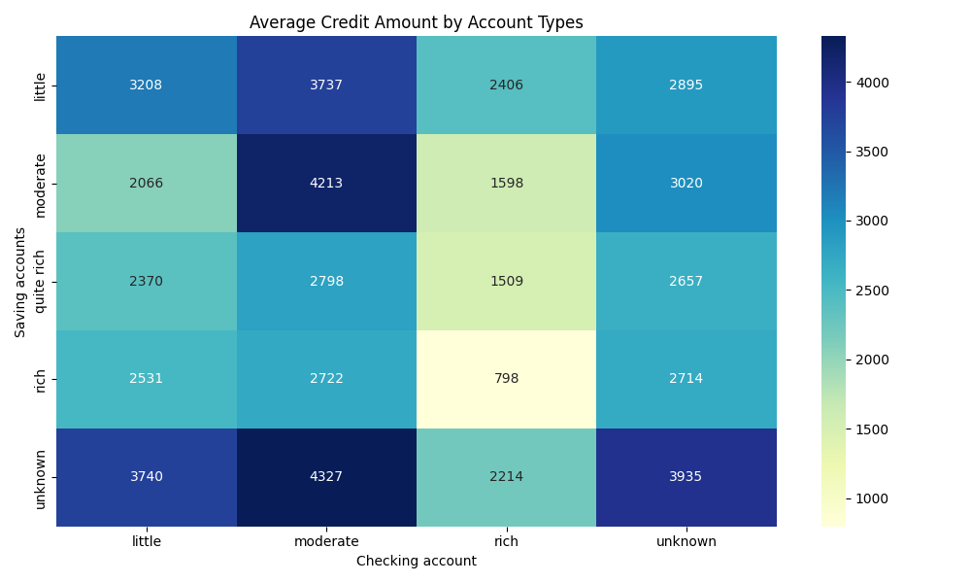
Analysis of Credit Amount by Purpose
General Description
These visualizations examine how credit amounts vary based on the stated purpose of the loan. The left plot shows average credit amount by purpose, while the right plot displays the distribution of credit amounts for each purpose category using boxplots.
Specific Requirements
The analysis aims to:
- Identify which loan purposes receive the highest and lowest average credit amounts
- Understand the distribution patterns for each purpose category
- Detect outliers and variation within each purpose category
- Compare central tendencies and dispersions across different loan purposes
Analysis Results
- Highest Credit Purpose: "Vacation/others" receives the highest average credit amount (approximately 8,000), significantly higher than all other categories
- Mid-Range Credit Purposes: "Business," "Car," and "Furniture/equipment" form a middle tier (3,000-4,000)
- Lower Credit Purposes: "Education," "Repairs," "Radio/TV," and "Domestic appliances" have the lowest average credit amounts
- Distribution Patterns:
  - "Vacation/others" shows both high average and wide distribution
  - "Business" loans have significant outliers up to approximately 15,000
  - "Car" loans show a cluster of outliers around 10,000
  - "Domestic appliances" has the narrowest distribution and lowest values
  - All categories except "Vacation/others" have median values below 2,500
Visualization
The dual visualization approach effectively communicates both central tendency (bar chart) and distribution characteristics (boxplot):
- Left Plot (Bar Chart): Shows clear ranking of average credit amounts by purpose, with purposes sorted from highest to lowest
- Right Plot (Boxplot): Reveals distribution details including:
  - Median (central line in each box)
  - Interquartile range (box width)
  - Outliers (individual points)
  - Range of non-outlier values (whiskers)
The visualization highlights that while "Vacation/others" has the highest average credit amount, it also has a wide distribution. Meanwhile, categories like "Domestic appliances" have more concentrated distributions with few outliers, suggesting more consistent lending patterns for those purposes.
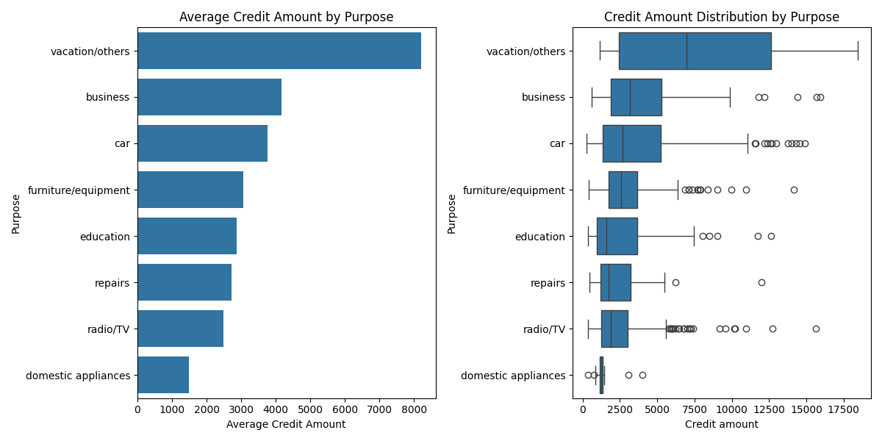
Analysis of Credit Amount by Demographic Factors
General Description
These four boxplots examine how credit amounts vary across different demographic characteristics: sex, age group, job category, and housing type. They're part of the demographic analysis section of the project, aimed at understanding how personal characteristics influence credit behaviors.
Specific Requirements
The analysis aims to:
- Compare credit amount distributions across gender groups
- Identify age-related patterns in credit amounts
- Examine how job category affects credit amounts
- Understand the relationship between housing type and credit amounts
- Detect potential outliers within demographic groups
Analysis Results
Credit Amount by Sex
- Males show a slightly higher median credit amount than females
- Males have more outliers in the upper range (10,000-15,000)
- The highest individual credit amount (approximately 18,000) belongs to a female borrower
- Overall distributions are similar, with most borrowers of both sexes receiving credits between 1,000-5,000
Credit Amount by Age Group
- Middle age groups (25-35 and 35-45) show slightly higher median credit amounts
- The 25-35 age group has the highest upper quartile (top of the box)
- Outliers exist across all age groups, suggesting high credit amounts aren't restricted to specific ages
- The oldest group (60-75) shows the narrowest distribution (excluding outliers)
Credit Amount by Job Category
- Job category 3 (likely highest skilled/professional) shows substantially higher median and quartile values
- Job category 0 (possibly unemployed/unskilled) has the lowest median credit amount
- Job category 2 has the most outliers in the upper range
- Job category 3 has the widest distribution, indicating more variability in credit amounts
Credit Amount by Housing Type
- "Free" housing type shows the highest median credit amount
- "Own" housing type has the most outliers in the upper range
- "Rent" housing type shows the lowest credit amounts overall
- The highest single credit amount appears in the "own" housing category
Visualization
The boxplot visualization effectively shows:
- Central tendency (median line)
- Distribution spread (box representing 25th to 75th percentiles)
- Range (whiskers)
- Outliers (individual points)
These visualizations reveal that job category and housing type have stronger relationships with credit amounts than sex or age group. Category 3 jobs and "free" housing are associated with higher credit amounts, which could inform lending decisions and risk assessments.
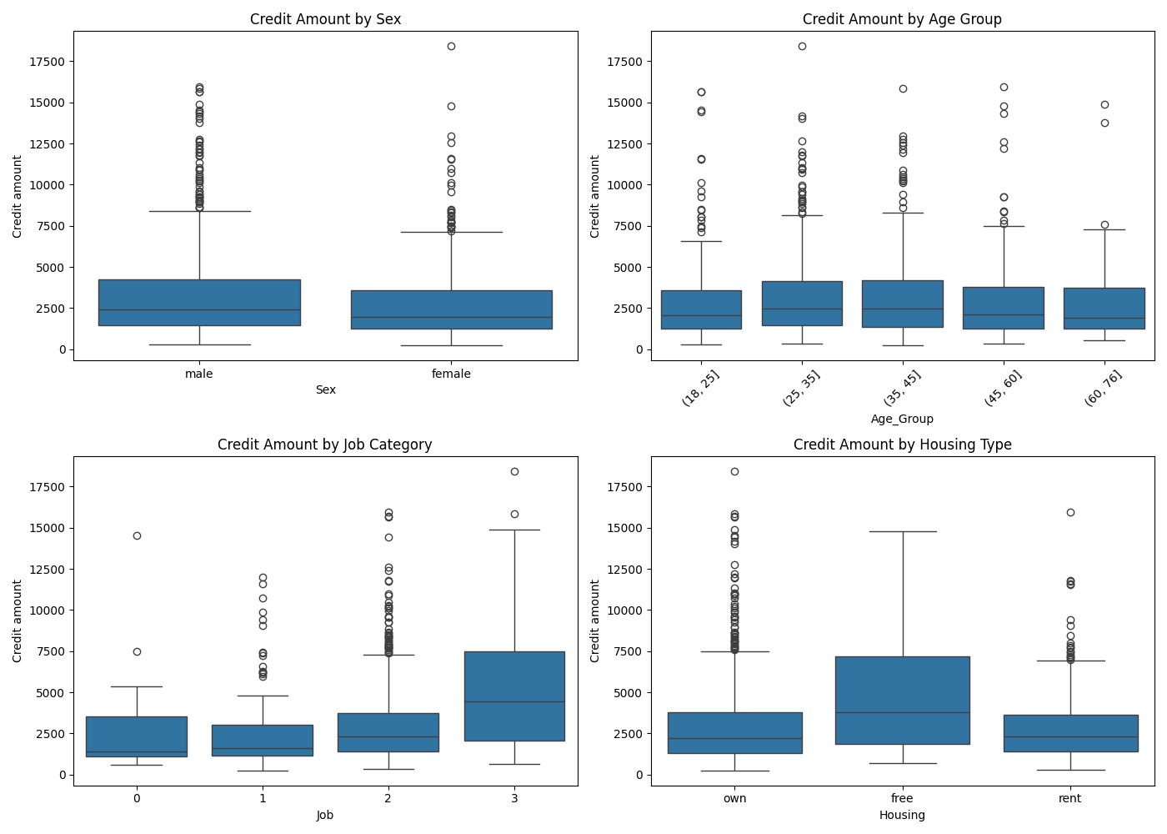

Analysis of Credit Amount Distribution
General Description
This histogram visualizes the overall distribution of credit amounts in the German credit dataset. It shows the frequency (count) of loans at different credit amount ranges, with a KDE (Kernel Density Estimate) curve overlaid to show the probability density function.
Specific Requirements
The analysis aims to:
- Understand the overall distribution pattern of credit amounts
- Identify the most common credit amount ranges
- Detect potential outliers in the dataset
- Determine if the distribution follows any standard statistical pattern (normal, exponential, etc.)
Analysis Results
- Distribution Shape: The distribution is right-skewed (positively skewed), with a long tail extending toward higher values
- Most Common Range: The highest concentration of credits falls between 1,000 and 2,500 units
- Central Tendency: The mode appears to be around 1,500-2,000 units
- Outliers: There are relatively few credits above 10,000, with the maximum reaching approximately 18,000
- Density Pattern: The KDE curve confirms the right-skewed nature and shows a rapid decline after about 5,000 units
Visualization
The histogram effectively communicates several key insights:
- Bars show the frequency count for each credit amount bin
- The smooth blue line represents the KDE, helping visualize the underlying distribution
- The x-axis spans the full range of credit amounts from 0 to approximately 18,000
- The y-axis shows the count of credits in each bin, peaking at around 160 for the most common range
This visualization reveals that while most credits are for relatively small amounts (under 5,000), there is a significant "tail" of larger credits. This pattern is common in financial data and suggests that risk assessment should pay particular attention to the relatively rare but impactful high-value credits. The distribution's shape also indicates that mean values would be pulled higher than median values, which could affect how summary statistics are interpreted.
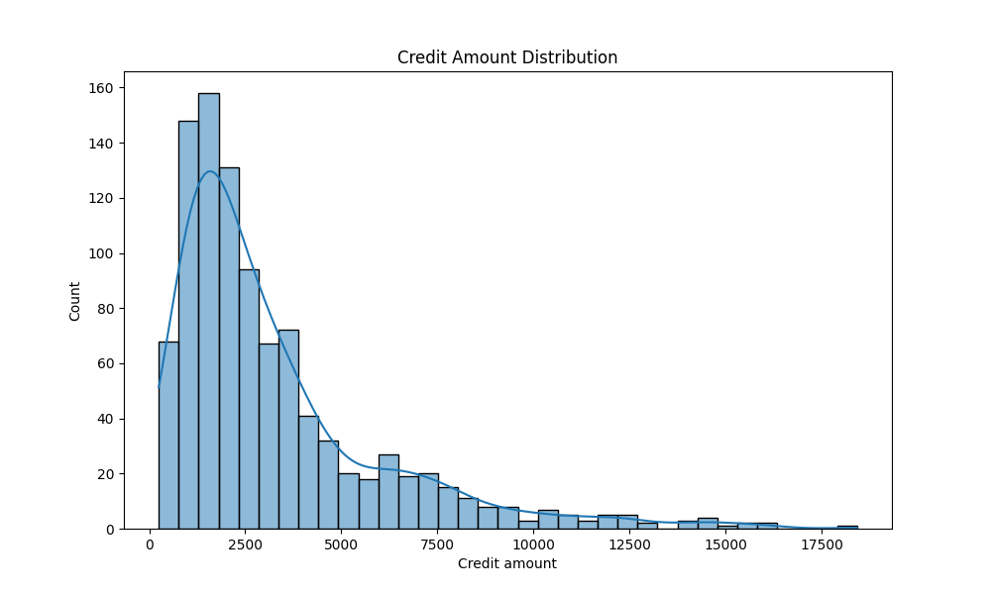
Analysis of Age Distribution by Sex
General Description
This histogram shows the age distribution of borrowers in the German credit dataset, segmented by sex (male and female). The visualization uses a stacked histogram approach where each bar represents an age bin, with the blue portion showing male counts and the orange portion showing female counts.
Specific Requirements
The analysis aims to:
- Compare age distributions between male and female borrowers
- Identify peak borrowing age ranges for each gender
- Detect gender-based patterns across different age groups
- Understand the overall age structure of the borrowing population
Analysis Results
- Overall Age Range: The dataset includes borrowers from approximately 20 to 75 years of age
- Gender Composition: Males represent a larger portion of borrowers across most age groups
- Female Age Distribution:
  - Highest concentration in the 20-30 age range
  - Sharp decline after age 30
  - Very few female borrowers above age 50
- Male Age Distribution:
  - Peaks around 25-30 years
  - More gradual decline across ages
  - Continues to have significant representation even in older age brackets (50-70)
- Age Group Patterns:
  - Young adults (20-25): More balanced gender ratio
  - Prime adults (25-45): Strong male predominance
  - Mature adults (45-75): Predominantly male borrowers
Visualization
The stacked histogram effectively communicates:
- The total count of borrowers at each age (total bar height)
- The gender breakdown at each age (blue vs. orange sections)
- The overall shape of the distribution (right-skewed with peak in 20s-30s)
This visualization reveals important demographic patterns in the credit dataset. The stark difference in gender distribution across age groups suggests different borrowing behaviors or access to credit between males and females, particularly for older age brackets. The financial institution might use this information to develop targeted products or outreach for specific demographic segments, particularly older females who appear underrepresented in the dataset.

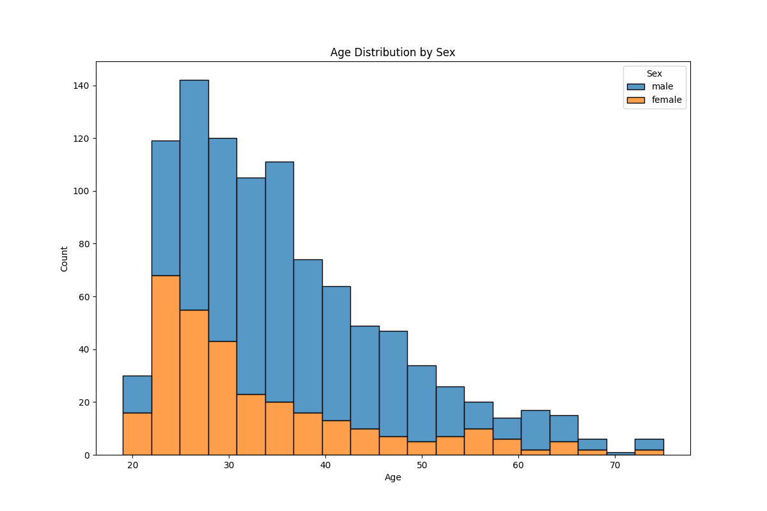
Analysis of Credit Amount vs Duration by Purpose
General Description
This scatter plot visualizes the relationship between credit amount (x-axis) and loan duration in months (y-axis), with points colored according to the purpose of the loan. The visualization allows for examining how these three variables interact and whether patterns exist across different loan purposes.
Specific Requirements
The analysis aims to:
- Identify relationships between credit amount and loan duration
- Detect purpose-specific patterns in credit amount and duration combinations
- Recognize clustering or common combinations of credit amount and duration
- Identify outliers in terms of unusually high credit amounts or long durations
Analysis Results
- General Relationship: There appears to be a slight positive relationship between credit amount and duration, though with considerable variability
- Duration Clustering: Strong horizontal banding at certain durations (particularly at 12, 24, 36, 48, and 60 months), indicating standardized loan terms
- Purpose-Specific Patterns:
  - "Car" loans (red points) appear across the entire plot but are especially common at standard durations
  - "Vacation/others" (gray points) tend toward higher credit amounts
  - "Radio/TV" and "Furniture/equipment" loans cluster at lower amounts and shorter durations
  - "Business" loans (purple) show some presence in higher credit amounts
- Outliers:
  - Several high-value loans (>12,000) with various purposes and durations
  - A few very long-term loans (60+ months), particularly for radio/TV
  - The highest credit amount appears to be for vacation/others at approximately 18,000 units
Visualization
The scatter plot effectively shows:
- The distribution of loans across the credit amount and duration dimensions
- Clear horizontal banding that reveals standard loan terms
- Color-coding that helps identify purpose-specific patterns
- The concentration of most loans in the lower-left region (lower amounts, shorter durations)
This visualization reveals that lending practices follow standardized terms for duration regardless of purpose, with certain amounts and durations being far more common than others. The relationship between credit amount and duration isn't strictly linear but follows institutional patterns with conventional loan terms. The color-coding by purpose adds valuable context, showing how different types of purchases are typically financed.
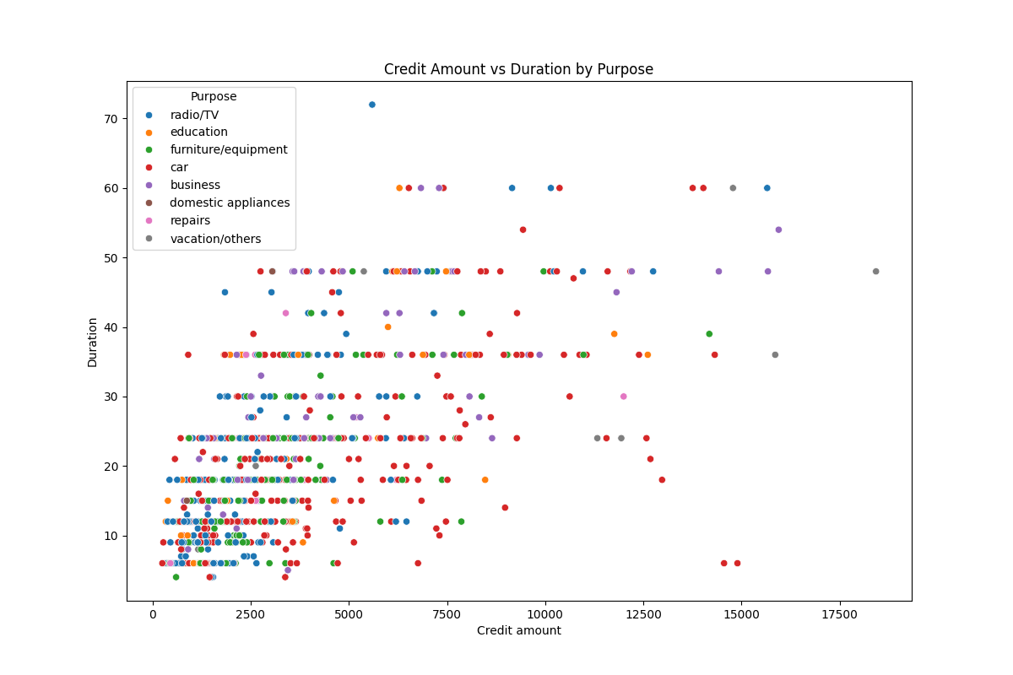
Analysis of Credit Amount and Duration Relationship
General Description
These two visualizations examine the relationship between loan duration and credit amount from different perspectives. The left plot shows a scatter plot with a regression line, while the right plot displays average credit amounts across different duration groups.
Specific Requirements
The analysis aims to:
- Quantify the relationship between credit duration and amount
- Measure the strength of correlation between these variables
- Show how average credit amount changes with loan duration
- Identify patterns in the raw data points and in aggregated groups
Analysis Results
- Correlation Strength: The scatter plot indicates a moderate-to-strong positive correlation of 0.625 between duration and credit amount
- Linear Relationship: The regression line shows a clear upward trend, with credit amounts increasing as duration increases
- Duration Patterns: Vertical clustering appears at standard loan durations (12, 24, 36, 48, 60 months), showing institutional preference for these terms
- Group Progression: The bar chart demonstrates a clear stepped increase in average credit amounts across duration groups
- Dramatic Growth: The longest duration group (48-72 months) has dramatically higher average credit amounts (approximately 10,000) compared to short-term loans (0-12 months) at approximately 1,800
Visualization
The complementary visualizations effectively communicate different aspects of the same relationship:
Left Plot (Scatter Plot with Regression):
- Individual data points show the actual distribution of loans
- The blue regression line indicates the linear relationship
- The shaded area represents the confidence interval for the regression
- Vertical clustering shows the preference for standard loan terms
- The correlation coefficient (0.625) is displayed in the x-axis label
Right Plot (Bar Chart):
- Simplifies the relationship by showing average credit amounts for each duration group
- Demonstrates the clear progression from short to long durations
- Shows approximately exponential growth in credit amounts as duration increases
- Makes the relationship more accessible through aggregation
These visualizations highlight that longer-term loans are consistently associated with higher credit amounts, with each duration band showing a substantial increase in average credit amount. This pattern likely reflects both institutional lending policies and borrower behavior, where larger purchases naturally require longer repayment periods.
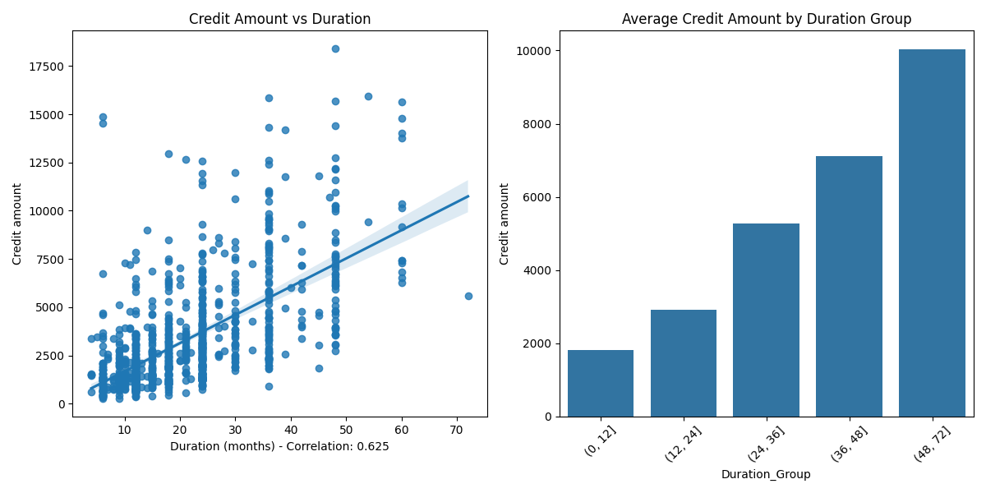

Analysis of Correlation Matrix
General Description
This visualization presents a correlation matrix that examines the relationships between four key numerical variables in the German credit dataset: Age, Job, Credit amount, and Duration. The heatmap uses color intensity to represent the strength and direction of correlations between each pair of variables.
Specific Requirements
The analysis aims to:
- Identify significant correlations between numerical variables
- Determine which factors are most strongly associated with credit amount
- Understand how demographic factors relate to credit parameters
- Detect potential predictive relationships for credit modeling
Analysis Results
- Strongest Correlation: Duration and Credit amount show the highest correlation (0.62), indicating a strong positive relationship
- Job Relationships:
  - Job has a moderate positive correlation with Credit amount (0.29)
  - Job also shows a weak positive correlation with Duration (0.21)
- Age Independence:
  - Age has virtually no correlation with Job (0.016)
  - Age has negligible correlation with Credit amount (0.033)
  - Age shows a slight negative correlation with Duration (-0.036)
- Key Insights:
  - The duration of a loan is the strongest predictor of its amount
  - Job category has moderate influence on both credit amount and duration
  - Age appears to be largely independent of other variables
Visualization
The correlation matrix heatmap effectively communicates:
- Correlation strength through color intensity (darker red for strong positive, darker blue for strong negative)
- Exact correlation values displayed in each cell for precision
- Perfect correlations (1.0) along the diagonal as expected
- Symmetrical pattern reflecting the nature of correlation measures
This visualization highlights that the strongest relationship in the credit dataset is between duration and amount, suggesting that longer loans are consistently associated with higher credit amounts. The job variable's moderate correlations suggest that employment category influences lending patterns, while age appears to play a minimal role in determining credit parameters. These insights could inform lending policies and risk models by focusing on the most relevant predictive factors.
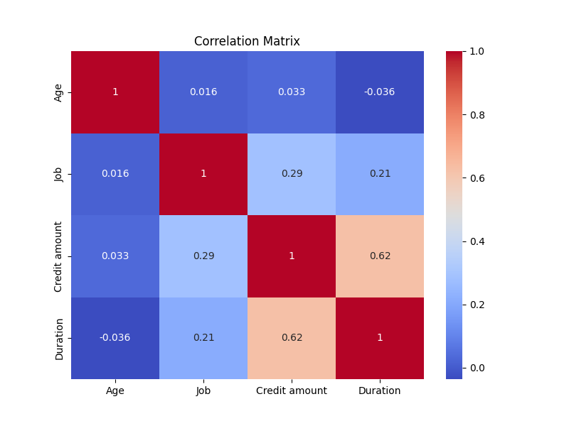
German Credit Data Analysis
1. General Description
This analysis explores a German credit dataset to understand credit risk factors. The code performs comprehensive exploratory data analysis including data loading, cleaning missing values, demographic analysis, credit behavior examination, and risk assessment. A custom risk scoring system evaluates borrowers based on multiple risk factors.
2. Specific Requirements
The analysis addresses the following key requirements:
- Examination of credit amount distribution across demographic factors (age, sex, job)
- Analysis of credit relationships with account types (savings and checking)
- Assessment of loan purpose impact on credit amount
- Development of risk indicators and a custom risk scoring system
- Visualization of credit-to-age and credit-to-duration ratios
3. Analysis Results
The risk assessment reveals:
- Most customers have low risk scores (0), with smaller numbers having moderate (1-2) or high (3) risk
- Business loans and vacation loans have higher average risk scores than other loan purposes
- Credit-to-age ratios show wide variation but mostly concentrate below 200
- Credit-to-duration ratios are primarily below 500, suggesting standard proportionality
- Risk is quantified using factors like high credit + long duration, absence of checking accounts, young age with high credit, and unemployment status
4. Visualization
The visualizations effectively communicate the risk analysis:
- The Risk Score Distribution chart shows the heavily skewed distribution toward low-risk customers
- The Risk Score by Purpose box plot reveals business and vacation loans carry higher risk profiles
- The Credit Amount to Age Ratio histogram demonstrates how credit amounts relate to customer age
- The Credit Amount to Duration Ratio histogram shows the relationship between loan amount and term
These visualizations provide clear insights into risk distribution patterns and relationships between credit amounts and key factors, supporting credit decision-making processes.
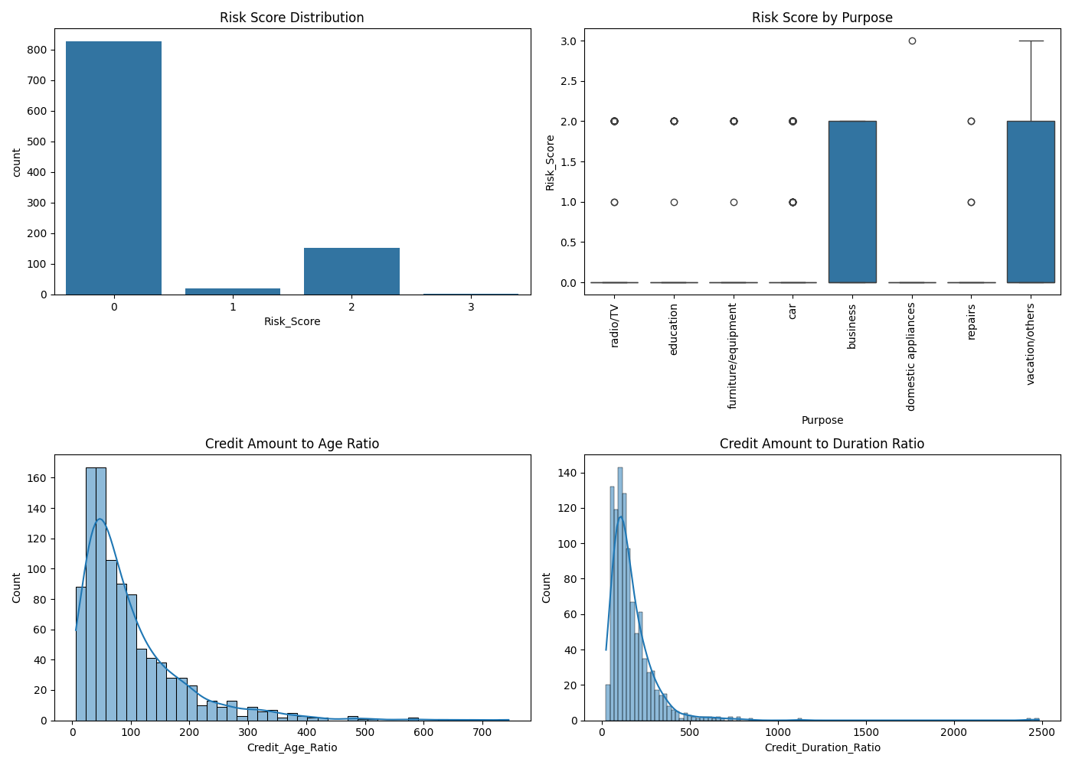

Conclusion
Analysis of the German credit dataset reveals several key lending patterns. Credit amounts are primarily influenced by account types, with customers having moderate checking accounts and unknown saving accounts receiving the highest amounts. Loan purpose significantly impacts credit allocation, with vacation loans receiving the highest amounts followed by business loans, though these also carry elevated risk profiles. A moderate positive correlation (0.625) exists between loan duration and credit amount, with longer terms associated with substantially higher credit amounts. Demographic factors show some influence—higher job categories receive larger loans, males have slightly higher median credit amounts than females, and middle-aged borrowers (25-45) receive more credit than younger or older applicants. The risk assessment identifies most customers as low-risk (score 0), with business and vacation loans demonstrating higher risk profiles. These findings suggest that lending decisions are predominantly based on account status, loan purpose, duration, and professional status rather than age or gender.

Future Scope
- Advanced Risk Modeling
  - Develop predictive models using machine learning algorithms (e.g., logistic regression, decision trees, or neural networks) to assess credit risk more accurately.
  - Incorporate additional risk factors such as income levels, debt-to-income ratios, and credit history to enhance the risk scoring system.
- Behavioral Analysis
  - Investigate the underlying reasons for the observed patterns, such as why customers with "rich" account statuses receive lower credit amounts or why business and vacation loans are associated with higher risk.
  - Conduct qualitative research (e.g., surveys or interviews) to validate findings and uncover borrower motivations.
- Dynamic Credit Policies
  - Design dynamic credit policies tailored to specific demographics (e.g., age groups, job categories) or loan purposes to optimize lending strategies.
  - Explore personalized credit offers based on risk profiles and borrower behavior.
- Feature Engineering
  - Create additional derived features, such as credit utilization ratios or repayment capacity metrics, to improve model performance.
  - Experiment with clustering techniques to segment borrowers into distinct groups for targeted analysis.
- Real-time Data Integration
  - Integrate real-time data sources (e.g., transaction history, economic indicators) to enable dynamic risk assessment and adaptive lending policies.
  - Explore the use of APIs to fetch up-to-date financial data for more accurate modeling.
- Ethical and Fair Lending Practices
  - Investigate potential biases in lending decisions, particularly concerning gender or age, and develop fairness-aware algorithms to ensure equitable credit distribution.
  - Align models with regulatory requirements and ethical lending standards.
- Longitudinal Studies
  - Analyze temporal trends in credit behavior to identify shifts in borrower preferences or economic impacts on lending patterns.
  - Track the performance of loans over time to refine risk assessment models.
- Interactive Dashboards
  - Develop interactive dashboards for financial institutions to visualize credit risk, borrower demographics, and loan performance in real time.
  - Include drill-down capabilities for deeper exploration of specific segments.
- Cross-Dataset Analysis
  - Merge the German credit dataset with other relevant datasets (e.g., macroeconomic data, regional employment statistics) to uncover broader trends.
  - Compare findings with credit datasets from other countries to identify universal vs. culture-specific patterns.
- Automated Decision Systems
  - Implement automated credit approval systems that leverage the insights from this analysis to streamline lending processes.
  - Incorporate explainable AI techniques to provide transparency in decision-making for borrowers and regulators.

References
- Programming Language:
  - Python (Primary language for data analysis and visualization)
- Libraries & Frameworks:
  - Pandas (Data manipulation and cleaning)
  - NumPy (Numerical computations)
  - Matplotlib (Basic data visualization)
  - Seaborn (Advanced statistical visualizations)
- Development Environment:
  - Jupyter Notebook / Google Colab (Interactive analysis and reporting)
- Version Control:
  - Git & GitHub (Code repository and collaboration)
- Data Sources:
  - CSV/Excel (Dataset storage and loading)
- Documentation & Reporting:
  - Microsoft Word (Report formatting)
  - Markdown (For GitHub README documentation)

LinkedIn Post

